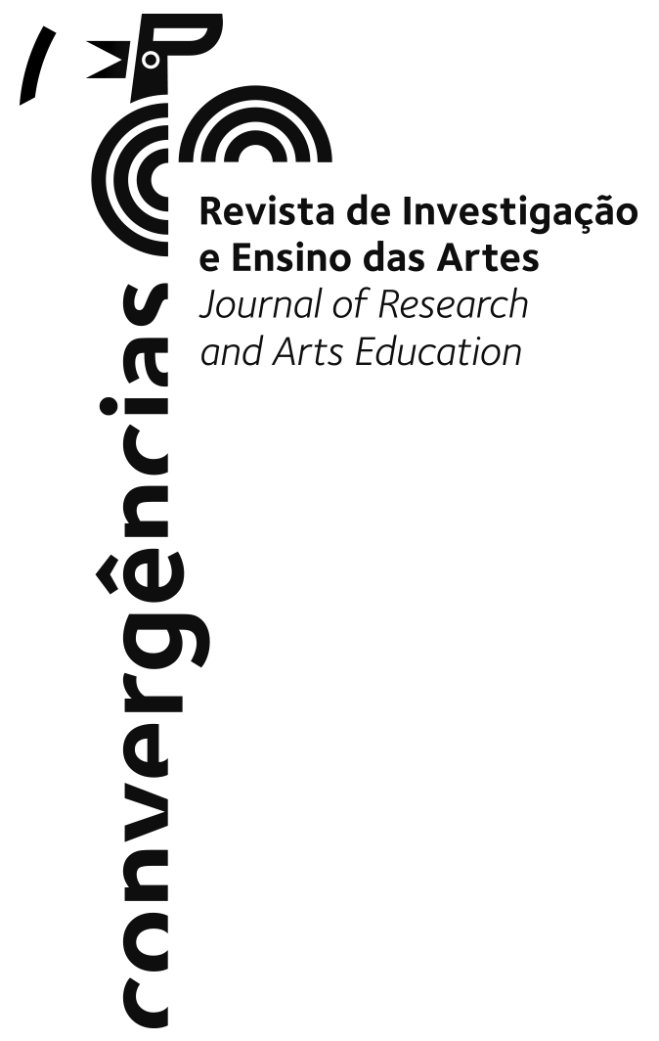

DECLARATION OF ORIGINALITY, DECLARATION OF AUTHORSHIP
AND CONSENT TO PUBLICATION

Manuscript title:

Full name, address and ORCID of the submitting author:

Full name, address and ORCID of corresponding author:

Full name, address and ORCID of co-authors:

1. By means of this declaration, the author who submitted the manuscript to Convergências Journal declares that:
- That the article is unpublished, i.e. not published in full or in part.
- That the people listed as authors of this manuscript have effectively contributed to it in terms of its conceptualisation, planning, organisation and execution of the work, in the interpretation of data and results, as indicated in the final version of the article according to CRedit - Taxonomy for Author Contribution.
- That authors have carried out a critical appraisal and review of the written content, approving the final version and agreeing to its publication.
- That authors assume authorship and responsibility for the content of the manuscript, guaranteeing the integrity, veracity and scientific rigour of the data presented, without having invented or manipulated them to bias results.
- That authors authorship of the original sources on which the manuscript is based is indicated, indicating the sources in accordance with the APA standard in its most recent edition, without containing plagiarised excerpts, paragraphs, figures or other content, and that they have authorisation to reproduce the text or graphic material they have authored from third parties.
- That authors have adopted and respect the ethical principles of research and have no conflict of interest to declare. Or that, if there is a conflict of interest, they have informed the editor-in-chief in advance and provided reasons.
- That due care has been taken to ensure the privacy rights of all parties directly and indirectly involved in the study, in the writing of the article and in the figures, anonymising as necessary to guarantee the protection of personal data. That the use of photographs with people or the data of individuals is done with their informed written consent.
- Whenever applicable, that the approval of the Ethics Committee and the Data Protection Committee has been obtained and that the participants have been duly informed of their rights.

2. By means of this declaration, the author who submitted the manuscript to Convergências Journal declares that:
- With the knowledge and on behalf of the other authors, you grant Convergências - Revista de Investigação e Ensino das Artes and Edições IPCB - Instituto Politécnico de Castelo Branco the right to publish, reproduce, copy, distribute, communicate, publicly display and otherwise make available the contribution identified above, including any associated supplementary information and elements, in any language.
- Authors are aware that the Convergências journal promotes and offers immediate open access without the need to register for reading, and that it is permitted to read, download, copy, distribute, print, search or reference the texts in part or in full, process them for indexing, as input data for software programmes, or use them for any other legal purpose, without financial barrier, within the legal, technical and licensing framework covered by Creative Commons CC BY.

Date:

Full name and signature:

